23 August 2021

To the faithful members of the Assyrian Church of the East, Archdiocese of Australia, New Zealand and Lebanon,
Blessings of the Lord with you all,

On September 5, 2021 the Holy Synod of the Assyrian Church of the East will convene at the patriarchal see, in Erbil, Iraq. Whereby the gathered prelates will proceed to elect the new Catholicos Patriarch for the see of Seleucia-Ctesiphon.

We ask that you keep our Holy Synod in prayer and supplication to our Lord and Saviour Jesus Christ, that the Almighty guides the prelates in the process of electing a new Catholicos Patriarch to lead our Holy Church in wisdom and diligence for the glory of God and the protection of our Assyrian nation for the years to come.

The grace of our Lord Jesus Christ upon you all.

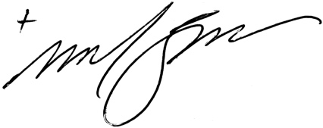
Mar Meelis Zaia AM
Archbishop of Australia, New Zealand & Lebanon

